

**Mawlana Bhashani Science and Technology University**

**Lab-Report**

Report No:04

Course code: ICT-3110

Course title: Operating System Lab

Date of Performance:04/09/2020

Date of Submission:10/09/2020

**Submitted by Submitted To**

Nazrul Islam

Assistant Professor

Dept. of ICT

MBSTU.

Name:Md Asikur Rahman

ID:IT-18025

3rd  year 1st semester

Session: 2017-2018

Dept. of ICT

MBSTU.

Experiment No:04

Experiment Name : File operation and permission

Aim and Objective :

To learn about file permission and operation in a linux pc and be able to use them in real live scenario and understand why they are needed and what could be done with them .

File Permission :

On Linux and other Unix-like operating systems, there is a set of rules for each file which defines who can access that file, and how they can access it. These rules are called file permissions or file modes. The command name chmod stands for "change mode", and it is used to define the way a file can be accessed.

In general, chmod commands take the form:

chmod options permissions filename

Each file on a system has associated with it a set of permissions which are used to protect files: a file's permissions determine which users may access that file, and what type of access they have to it.

There are three general classes of users:

* The user who [owns](https://www.computerhope.com/jargon/o/owner.htm) the file ("User")
* Users belonging to the file's defined ownership group ("Group")
* Everyone else ("Other")

In turn, for each of these classes of user, there are three types of file access:

* The ability to look at the contents of the file ("Read")
* The ability to change the contents of the file ("Write")
* The ability to run the contents of the file as a program on the system ("Execute")

So, for each of the three classes of user, there are three types of access. Taken together, this information makes up the file's permissions.

There are two ways to represent a file's permissions: symbolically (using symbols like "r" for read, "w" for write, and "x" for execute) or with an [octal](https://www.computerhope.com/jargon/o/octal.htm) numeric value.

* 4 stands for "read",
* 2 stands for "write",
* 1 stands for "execute", and
* 0 stands for "no permission."

So 7 is the combination of permissions 4+2+1 (read, write, and execute), 5 is 4+0+1(read, no write, and execute), and 4 is 4+0+0 (read, no write, and no execute).

Commands :

ls – l :This command shows all the file in the current directory with there permission

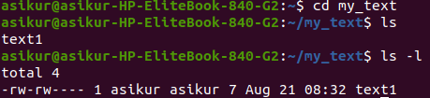

Permission for a particular file could be seen by typing the file name after the existing command



chmod :

this command can be various ways . If a file named text1 is to be given the permission to be read , write and to be executed for the user and to be read ,executed by the group and give no

This could be also done by octal in that case for user 7 (4+2+1), for group 5(4+1) and for others it would be 0 now if the group is to be given permission to write then

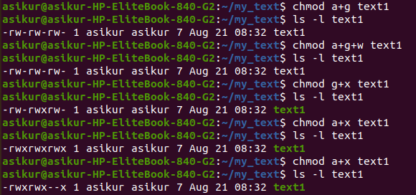

to give other user permission to execute text1

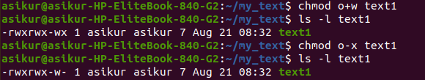

the code is written in text1

Now as the permission is given we can execute the file



Discussion :

This is one of the most important lab so far as we learnt about various kinds of users and operations and how to set permission for different users , how to add or remove different set of permissions for a or a set of users .